IOT ENABLED SMART FARMING APPLICATION

Team ID: **PNT2022TMID53961**

**BY**

**TEAM LEADER : JOYSONVASHIKARAN A**

TEAM MEMBERS:

JEGADISH A

GNANAESWARAMOORTHY M

ABRAHAM P

**INTRODUCTION:**

In order to meet the current global needs of humanity, new solutions and technologies are constantly being proposed and implemented. This has led to the advent of the Internet of Things (IoT) . IoT is defined as the network of all objects that are embedded within devices, sensors, machines, software and people through the Internet environment to communicate, exchange information and interact in order to provide a comprehensive solution between the real world and the virtual world . In recent years, IoT has been applied in a series of domains, such as smart homes , smart cities , smart energy , autonomous vehicles , smart agriculture , campus management , healthcare , and logistics . Series of other IoT applications have been described by Shafique et al.

Over the years, wireless sensor networks (WSN) have been strongly applied in the agricultural sector, building the foundation for developing smart agriculture . The unique characteristics of WSN, such as the ability to self-organize, self-configure, self-establish, and self-recover, make it suitable for smart agriculture . The sensor device consists of a radio frequency transceiver, sensor, microcontroller, and battery power .

**PROJECT OVERVIEW:**

The growth of the global population coupled with a decline in natural resources, farmland,

and the increase in unpredictable environmental conditions leads to food security is becoming a major

concern for all nations worldwide. These problems are motivators that are driving the agricultural

industry to transition to smart agriculture with the application of the Internet of Things (IoT) and

big data solutions to improve operational efficiency and productivity. The IoT integrates a series

of existing state-of-the-art solutions and technologies, such as wireless sensor networks, cognitive

radio ad hoc networks, cloud computing, big data, and end-user applications. This study presents

a survey of IoT solutions and demonstrates how IoT can be integrated into the smart agriculture

sector. To achieve this objective, we discuss the vision of IoT-enabled smart agriculture ecosystems

by evaluating their architecture (IoT devices, communication technologies, big data storage, and

processing), their applications, and research timeline. In addition, we discuss trends and opportunities

of IoT applications for smart agriculture and also indicate the open issues and challenges of IoT

application in smart agriculture. We hope that the findings of this study will constitute important

guidelines in research and promotion of IoT solutions aiming to improve the productivity and quality

of the agriculture sector as well as facilitating the transition towards a future sustainable environment

with an agroecological approach

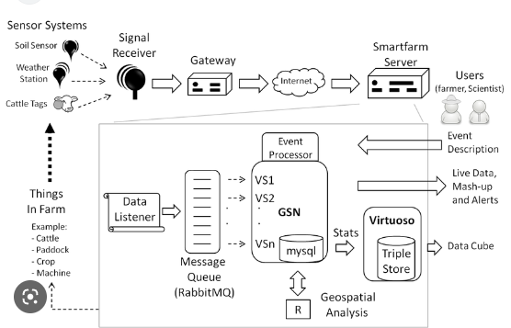

PURPOSE:

automation, and traceability . Along with the development of science and technology, the urgent requirement for breakthrough solutions and technologies aiming at improving productivity and efficiency in the agriculture sector has led to adoption of the IoT. The primary motivation for their applications is the breakthrough progress of smart agriculture and its inevitable role as the future of smart and sustainable environment management. IoT integrates a series of existing solutions and technologies, such as WSN, cognitive radio, ad hoc networks, cloud computing, and end-user applications . In the smart agricultural sector, automation solutions and technologies, mechanical machines, knowledge, decision-making tools, services, and software are integrated seamlessly to help farmers improve productivity, product quality, and profitability . Figure 1. An illustration of IoT applications for smart agriculture. According to the United Nations’ (UN 2019) statistics, the world population is estimated to grow to 10 billion by 2050 . As a consequence, the requirements of agricultural products are continually increasing. However, farmlands are declining, natural resources are increasingly depleted, and the rise of unpredictable nature challenges, such as global warming, salinization, and flooding, make food security the most concerning problem for all nations worldwide. In recent years, with the aim of increasing agricultural production, new solutions and technologies have been introduced in the agriculture sector . An emerging trend is the application of the IoT and big data. A significant number of studies have been focused on research, experiments, and applications . According to the Cisco forecast, over 500 billion IoT devices will be connected to the Internet by 2030 . The use of IoT and big data will enable smart agriculture and is expected to enhance efficiency and productivity . Over the years, wireless sensor networks (WSN) have been strongly applied in the agricultural sector, building the foundation for developing smart agriculture . The unique characteristics of WSN, such as the ability to self-organize, self-configure, self-establish, and self-recover, make it suitable for smart agriculture . The sensor device consists of a radio frequency (RF) transceiver, sensor, microcontroller, and battery power . The WSN focuses on applications such as environmental monitoring, machine control automation, and traceability

LITERATURE SURVEY:

Along with the development of science and technology, the urgent requirement for

breakthrough solutions and technologies aiming at improving productivity and efficiency

in the agriculture sector has led to adoption of the IoT. The primary motivation for their

applications is the breakthrough progress of smart agriculture and its inevitable role as

the future of smart and sustainable environment management. IoT integrates a series of

existing solutions and technologies, such as WSN, cognitive radio, ad hoc networks, cloud

computing, and end-user applications . In the smart agricultural sector, automation

solutions and technologies, mechanical machines, knowledge, decision-making tools, services, and software are integrated seamlessly to help farmers improve productivity, product

quality, and profitability

In this work, a comprehensive survey of IoT applications for smart agriculture is

conducted. An analysis of 135 relevant works published between 2017 and 2022 was conducted. Firstly, relevant 550 papers published in the period of (2017–2022) were retrieved

from major scientific databases, namely IEEE Xplore Digital Library, Science Direct, MDPI,

and Springer, by using keywords such as IoT-enabled smart agriculture, smart agriculture,

Internet of Things, aquaponics, monitoring forestry based on IoT, tracking and tracing,

smart precision farming, greenhouse production, Sigfox, LoRa, Wi-Fi, LoRaWAN, and

IoT ecosystems. In the next step, we excluded papers that were published in low-repute

conferences and journals, and then we conducted the content analysis for the obtained

paper.

EXISTING PROBLEM:

farming is the practice of cultivating plants and livestock.[1] Agriculture was the key development in the rise of sedentary human civilization, whereby farming of domesticated species created food surpluses that enabled people to live in cities. The history of agriculture began thousands of years ago. After gathering wild grains beginning at least 105,000 years ago, nascent farmers began to plant them around 11,500 years ago. Sheep, goats, pigs and cattle were domesticated over 10,000 years ago. Plants were independently cultivated in at least 11 regions of the world. Industrial agriculture based on large-scale monoculture in the twentieth century came to dominate agricultural output, though about 2 billion people still depended on subsistence agriculture.

The major agricultural products can be broadly grouped into foods, fibers, fuels, and raw materials (such as rubber). Food classes include cereals (grains), vegetables, fruits, cooking oils, meat, milk, eggs, and fungi. Over one-third of the world's workers are employed in agriculture, second only to the service sector, although in recent decades, the global trend of a decreasing number of agricultural workers continues, especially in developing countries.

IDEATION AND PURPOSE SOLUTION:

Embedded systems are programmable interactive modules, namely FPGAs (field

programmable gate arrays). Sensor devices are specially designed to operate in open

environments, in nature, in soil, water, and air to measure and collect environmental

parameters that affect production, such as soil nutrients, humidity, temperature, etc. Smart

farming solutions are agricultural operations that are often deployed on large farmlands,

outdoors, so the devices that support solutions need some unique characteristics, such

as the ability to withstand the effects of weather, humidity, and temperature instability

throughout their service lifecycle.

IoT Devices

The common architecture of an IoT device consists of sensors to collect information

from the environment, actuators based on wired or wireless connections, and an embedded system that has a processor, memory, communication modules, input–output interfaces, and battery power . The common architecture of a typical IoT device for smart. An illustration of the common architecture of a IoT device.

Embedded systems are programmable interactive modules, namely FPGAs (field

programmable gate arrays). Sensor devices are specially designed to operate in open environments, in nature, in soil, water, and air to measure and collect environmental parameters that affect production, such as soil nutrients, humidity, temperature, etc. Smart farming solutions are agricultural operations that are often deployed on large farmlands, outdoors, so the devices that support solutions need some unique characteristics, such as the

ability to withstand the effects of weather, humidity, and temperature instability throughout their service lifecycle.

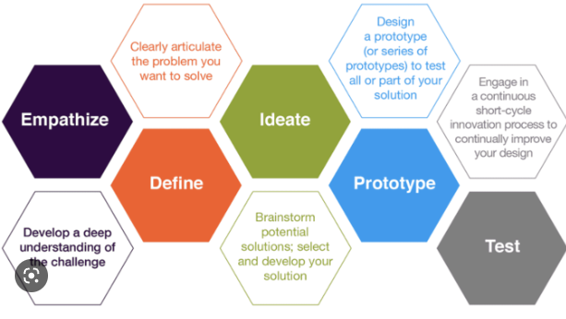

PROJECT DESIGN:

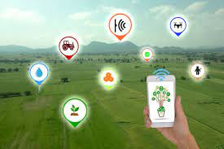

Subsurface Drip Irrigation (SDI) is already a prevalent irrigation method that allows farmers to control when and how much water their crops receive.  By pairing these SDI systems with increasingly sophisticated IoT-enabled sensors to continuously monitor moisture levels and plant health, farmers will be able to intervene only when necessary, otherwise allowing the system to operate autonomously.

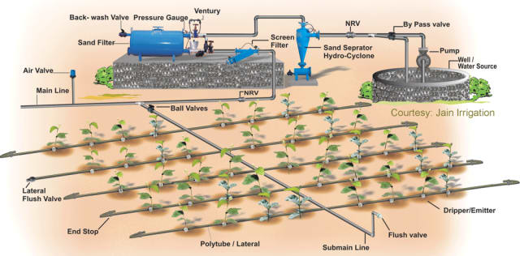

Example of an SDI system for agriculture. While current systems often require the farmer to manually check lines and monitor the pumps, filters and gauges, future farms can connect all this equipment to sensors that stream monitoring data directly to a computer or smartphone. (Image courtesy of Jain Irrigation.)

While SDI systems aren’t exactly robotic, they could operate completely autonomously in a smart farm context, relying on data from sensors deployed around the fields to perform irrigation as needed.

**Weeding and Crop Maintenance**

Weeding and pest control are both critical aspects of plant maintenance and tasks that are perfect for autonomous robots.  A few prototypes are already being developed, including [Bonirob](http://www.engineering.com/AdvancedManufacturing/ArticleID/11184/Robotic-Automation-Meets-Agriculture.aspx" \t "_blank) from Deepfield Robotics, and an automated cultivator that is part of the [UC Davis Smart Farm](https://www.ucdavis.edu/news/smart-farm) research initiative.

The Bonirob robot is about the size of a car and can navigate autonomously through a field of crops using video, LiDAR and satellite GPS. Its developers are using machine learning to teach the Bonirob to identify weeds before removing them. With advanced machine learning, or even [artificial intelligence](https://www.engineering.com/DesignerEdge/DesignerEdgeArticles/ArticleID/14723/Artificial-Intelligence-and-Engineering.aspx) (AI) being integrated in the future, machines such as this could entirely replace the need for humans to manually weed or monitor crops

Data flow diagram:

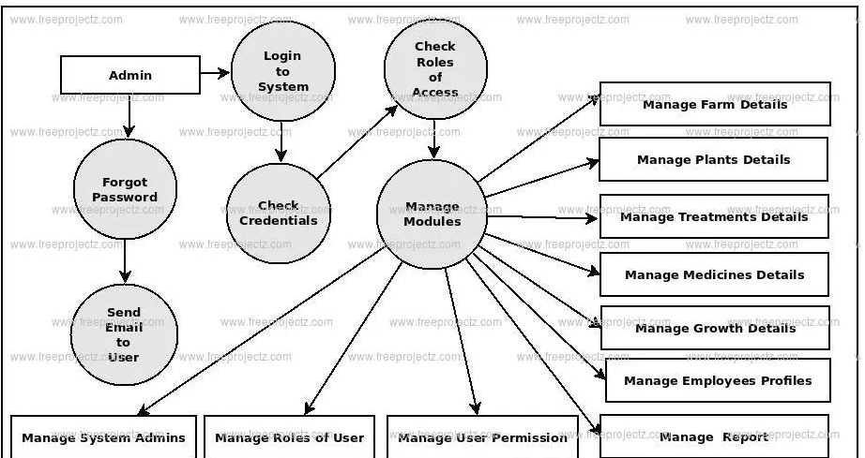

Typical Applications of IoT in Smart Agriculture:

In recent years, a series of IoT applications for agriculture have been introduced. According to survey results, we divided these applications into categories based on their purpose, including monitoring, tracking and traceability, and greenhouse production. The detailed results are presented in the following subsection. 3.1. Monitoring In the agriculture sector, factors affecting the farming and production process can be monitored and collected, such as soil moisture, air humidity, temperature, pH level, etc. Appl. Sci. 2022, 12, 3396 8 of 19 These factors depend on the considered agricultural sector. Some smart agricultural sectors are applying the following monitoring solutions: Crop Farming: In this sector, some vital factors that affect the farming process and production efficiency include air temperature, precipitation, air humidity, soil moisture, salinity, solar radiation, pest status, soil nutrient ingredients, etc. In [81], the authors designed an IoT device called FarmFox. This device allows real-time collection and analysis of the composition of the farming soil and transmits the information to farmers/owners via the Internet. The results demonstrate the health of the soil is monitored in real time to provide timely recommendations to farmers aiming to increase productivity and farming efficiency

Furthermore, in [82], the authors proposed an IoT device to allow intelligent control of temperature and humidity factors, called a weather radar. This device will automatically turn on the warning mode using the light signal and send messages to the farmer when the temperature or humidity exceeds a pre-installed threshold. In [83], the authors introduced an IoT system based on Web GIS to monitor pest status and provide early warnings. In addition, this study also proposes a predictive model based on monitoring the habitat of pests and diseases. The efficiency of the proposed system was indicated, based on the predicted figures of the locust epidemic, to have a high accuracy rate (over 87%)

TRACKING AND TRACING:

In order to meet the needs of consumers and increase profit value, in the future, farms need to demonstrate that products offered to the market are clean products and can be tracked and traced conveniently, thereby enhancing the trust of consumers in product safety and health-related issues. In order to solve this problem, a series of tracking- and tracing-based problems for the smart agricultural sector has been proposed, specifically as follows: In [96], the authors designed an information system that allows tracking and tracing of agricultural products and foods such as dairy and vegetables, called SISTABENE. This system helps suppliers track the production process and errors arising in the supply chain, and helps end-users trace the origin of food. In [97], the authors proposed a food supply chain traceability system based on blockchain technology. It helps to track and trace agrifood supply chains’ production process and trace the origin of agricultural products. This solution has been employed at Shanwei Lvfengyuan Modern Agricultural Development Co., Ltd. (Shanwei, China). Although there are still limitations, the results demonstrate that this solution has successfully supported the tracing of food and agricultural products through QR codes, improving product quality and ensuring the clear traceability of products. In [98,99], the authors proposed smart agricultural solutions to tracking and tracing agricultural products, thereby allowing consumers to know the product’s entire history

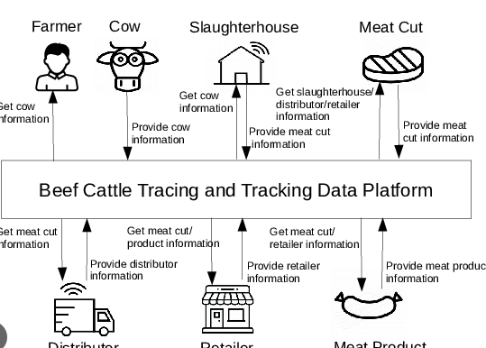

SMART PRECISION FARMING:

The advent of the GPS (global positioning system) has created breakthrough advances in many fields of science and technology. The GPS provides the most important parameters for locating a device, such as location and time. GPS systems have been successfully deployed in many fields, such as smartphones, vehicles, and IoT ecosystems. However, GPS is only good support for outdoor systems and the sky. Meanwhile, the demand for the locating and navigating systems in the home and on the streets of smart cities is growing rapidly. Aiming to solve this problem, an advanced global navigation satellite system (GNSS) is being deployed . Based on GPS and GNSS systems, suitable farming maps have been established for fields and farms. As a result, agricultural machinery and equipment can be operated autonomously [101]. Figure 6 presents an illustration of the typical cloud-assisted, IoT-based precision agriculture platform

Greenhouse Production A greenhouse consists of walls and a roof, which are usually made from transparent materials, such as plastic or glass. In a greenhouse, plants are grown in a controlled environment, including controlling for moisture, nutrient ingredients of the soil, light, temperature, etc. Consequently, greenhouse technology makes it possible for humans to grow any plant, at any time, by providing suitable environmental conditions . illustrates a smart agriculture IoT system for monitoring greenhouse farming factors based on IoT ecosystems. In , the authors introduced an IoT-based greenhouse environmental monitoring system for multipoint monitoring in large greenhouses. Instead of using multiple sensors at different locations, this solution involves a drive system that allows the sensor system diffliihhThillhhhFigure 6. Cloud-assisted IoT-based precision agriculture platform. In smart precision farming, one of the most important applications is the use of drones in monitoring and farming activities. Some common farming tasks using UAVs include spraying pesticides, fertilizing, sowing seeds, evaluating and mapping, and monitoring crop growth. In , the authors presented a detailed survey of drone applications for smart agriculture, including applications, control technology, and future trends of the UAV application for smart agriculture. In [103], the authors designed an automatic agricultural product classification system based on camera systems, image processing algorithms, and

GREENHOUSE PRODUCTION:

A greenhouse consists of walls and a roof, which are usually made from transparent materials, such as plastic or glass. In a greenhouse, plants are grown in a controlled environment, including controlling for moisture, nutrient ingredients of the soil, light, temperature, etc. Consequently, greenhouse technology makes it possible for humans to grow any plant, at any time, by providing suitable environmental conditions illustrates a smart agriculture IoT system for monitoring greenhouse farming factors based on IoT ecosystems

The authors introduced an IoT-based greenhouse environmental monitoring system for multipoint monitoring in large greenhouses. Instead of using multiple sensors at different locations, this solution involves a drive system that allows the sensor system to move to different locations in the greenhouse. The experimental results show that the proposed system can effectively monitor multiple points in large greenhouses. the Appl. Sci. 2022, 12, 3396 12 of 19 authors introduced an energy-saving temperature control technology for smart greenhouses. This study proposed two intelligent control methods: active disturbance rejection control and fuzzy active disturbance rejection control. The experimental results demonstrate that the proposed technology saves over 15% of the total energy consumption of the greenhouse, the authors designed an intelligent IoT system to monitor and control greenhouse temperature for energy efficiency and improve crop productivity. The experimental results for the Kingdom of Saudi Arabia, where daytime temperatures can be above 50 ◦C, demonstrate the efficiency of the proposed solution, including saving energy and predicting the rate of plant growth. Recent studies indicated that solutions integrating IoT, big data processing, and artificial intelligence could be applied in greenhouses to reduce labour and energy efficiency. Moreover, it also provides direct connections between the greenhouse farms and the customer .

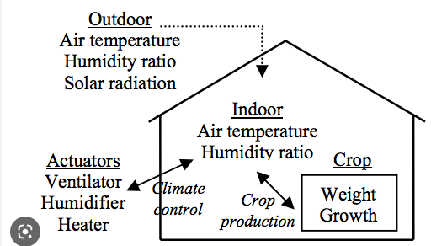

CHALLENGES AND OPEN RESEARCH SIRECTIONS:

The survey results indicate that IoT components for the smart agriculture sector, including hardware and software, have been focused on research and achieved many breakthrough results. Several IoT solutions have been deployed on large-scale farms/fields. However, the widespread deployment of IoT in the agricultural sector still presents some challenges. We have present two main problems: economic efficiency and technical problems. We consider these issues coupled with policies that will drive the integration of IoT technologies in agriculture.

Economic Efficiency In agricultural economics:

one of the most important characteristics is a low rate of profit of an investment project, which presents many risks from natural conditions. The benefit–cost of a new technology seeking deployment in agriculture should be carefully calculated to ensure a trade-off between the cost of technology implementation and the profit potential. Therefore, we discuss the economic aspects related to IoT implementation in smart agriculture. There are several types of costs related to the implementation of IoT in agriculture. We divided them into categories, including (1) the system initialization cost and (2) the system operating cost. The system initialization cost includes hardware purchases (IoT devices, gateways, base station infrastructure). The system operating cost includes service registration cost and the cost of labour to manage IoT devices. Furthermore, additional operating costs include incurred costs from energy consumption, maintenance, data exchange among IoT devices, gateways and cloud servers. According to the opinion of Turgut and Boloni , the successful deployment of the IoT technologies will only happen if the customer benefits (customers need to know the benefits and potential) that IoT systems provide exceed their physical value and privacy costs. The businesses participating in the IoT domain will profit and achieve success

According to the opinion of the service user (farmers or the owner of the farm), Equation (1) shows that the perceived value of the service for the user (Vservice) must be higher than the total of costs, including: the cost of the loss of privacy (Cpri), the equipment and hardware costs the user pays (C user h ), and the payments for the service fee (Cpay), while the opinion of the service provider, as shown in Equation (2), shows that the received information value (Vin f o) and the received direct payments (Rpay) must be higher than the share of the hardware and maintenance costs of the business (C business h ).

TECHNICAL PROBLEMS:

Interference: Deploying a huge number of IoT devices for smart agriculture can cause interference to different network systems, especially some IoT networks using short spectrum bands such as ZigBee, Wi-Fi, Sigfox, and LoRa (See Table 1). Interference can degrade system performance as well as reduce the reliability of IoT ecosystems. IoT networks that use cognitive technology to reuse unlicensed spectra increase the cost of the device. In our opinion, the advent of the 6G network will allow a huge number of devices to connect to the Internet with an extremely high access speed and extremely large bandwidth. The full interference problem of IoT networks will be solved. Security and Privacy: One of the most important problems of applying IoT in smart agriculture is the security problem, including the protection of data and systems from attacks on the Internet. In regard to system security, IoT devices’ limited capacity and ability led to complex encryption algorithms that are impossible to implement on IoT devices. As a result, IoT systems can be attacked using the Internet to gain system control rights; IoT gateways are also attacked via denial of service . In addition, cloud servers can be attacked by data spoofing to perform unauthorized tasks that affect the autonomous farming processes of farms. Cloud infrastructures can also be controlled by attackers . Several issues of detailed IoT data privacy and security measures have been discussed in . According to Neshenko et al., the IoT data security issue is one of the biggest problems slowing down IoT adoption in smart agriculture

Embedded systems are programmable interactive modules, namely FPGAs (field programmable gate arrays). Sensor devices are specially designed to operate in open environments, in nature, in soil, water, and air to measure and collect environmental parameters that affect production, such as soil nutrients, humidity, temperature, etc. Smart farming solutions are agricultural operations that are often deployed on large farmlands, outdoors, so the devices that support solutions need some unique characteristics, such as the ability to withstand the effects of weather, humidity, and temperature instability throughout their service lifecycle. Some of their main features, as shown in Figure 4, make IoT devices suitable for smart agriculture solutions IoT Devices The common architecture of an IoT device consists of sensors to collect information from the environment, actuators based on wired or wireless connections, and an embedded system that has a processor, memory, communication modules, input–output interfaces, and battery power . The common architecture of a typical IoT device for smart agriculture is shown in Figure 3. Figure 3. An illustration of the common architecture of an IoT device. Embedded systems are programmable interactive modules, namely FPGAs (field programmable gate arrays). Sensor devices are specially designed to operate in open environments, in nature, in soil, water, and air to measure and collect environmental parameters that affect production, such as soil nutrients, humidity, temperature, etc. Smart farming solutions are agricultural operations that are often deployed on large farmlands, outdoors, so the devices that support solutions need some unique characteristics, such as the ability to withstand the effects of weather, humidity, and temperature instability throughout their service lifecycle. Some of their main features make IoT devices suitable for smart agriculture solutions

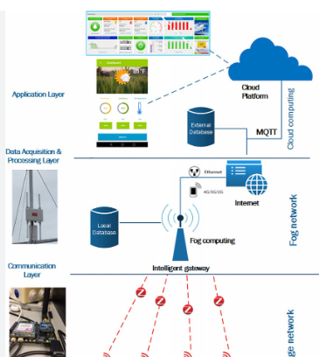

Conclusion:

In this study, we presented an overview of IoT and big data for the smart agriculture sector. Several issues related to promoting IoT deployment in the agriculture sector have been discussed in detail. Survey results indicate that many studies have been performed to apply IoT for smart agriculture, aiming to enhance productivity, reduce human labour, and improve production efficiency. The benefits of applying IoT and big data in agriculture were discussed. In addition, we also pointed out the challenges we need to overcome to be able to accelerate the deployment of IoT in smart agriculture. However, there are still some challenges that need to be addressed for IoT solutions to be affordable for the majority of farmers, including small- and medium-scale farm owners. In addition, security technologies need to be continuously improved, but in our opinion, the application of IoT solutions for smart agriculture is inevitable and will enhance productivity, provide clean and green foods, support food traceability, reduce human labour, and improve production efficiency. On the other hand, this survey also points out some interesting research directions for security and communication technologies for IoT. We think that these will be very exciting research directions in the future.

REFERENCES:

1. Quy, V.K.; Nam, V.H.; Linh, D.M.; Ngoc, L.A.; Gwanggil, J. Wireless Communication Technologies for IoT in 5G: Vision, Applications, and Challenges. Wirel. Commun. Mob. Comput. 2022, 2022, 3229294. [CrossRef]

2. Sinche, S.; Raposo, D.; Armando, N.; Rodrigues, A.; Boavida, F.; Pereira, V.; Silva, J.S. A Survey of IoT Management Protocols and Frameworks. IEEE Commun. Surv. Tutor. 2020, 22, 1168–1190. [CrossRef]

3. Elijah, O.; Rahman, T.A.; Orikumhi, I.; Leow, C.Y.; Hindia, M.N. An Overview of Internet of Things (IoT) and Data Analytics in Agriculture: Benefits and Challenges. IEEE Internet Things J. 2018, 5, 3758–3773. [CrossRef]

4. Li, W.; Logenthiran, T.; Phan, V.; Woo, W.L. A Novel Smart Energy Theft System (SETS) for IoT-based Smart Home. IEEE Internet Things J. 2019, 6, 5531–5539. [CrossRef]

5. Shin, D.; Yun, K.; Kim, J.; Astillo, P.V.; Kim, J.-N.; You, I. A Security Protocol for Route Optimization in DMM-Based Smart Home IoT Networks. IEEE Access 2019, 7, 142531–142550. [CrossRef]

6. An, J.G.; Le Gall, F.; Kim, J.; Yun, J.; Hwang, J.; Bauer, M.; Zhao, M.; Song, J.S. Toward Global IoT-Enabled Smart Cities Interworking Using Adaptive Semantic Adapter. IEEE Internet Things J. 2019, 6, 5753–5765. [CrossRef]

7. Cirillo, F.; Gomez, D.; Diez, L.; Maestro, I.E.; Gilbert, T.B.J.; Akhavan, R. Smart City IoT Services Creation through Large-Scale Collaboration. IEEE Internet Things J. 2020, 7, 5267–5275. [CrossRef]

8. Ammad, M.; Shah, M.A.; Islam, S.U.; Maple, C.; Alaulamie, A.A.; Rodrigues, J.J.P.C.; Mussadiq, S.; Tariq, U. A Novel Fog-Based Multi-Level Energy-Efficient Framework for IoT-Enabled Smart Environments. IEEE Access 2020, 8, 150010–150026. [CrossRef]

9. Metallidou, C.K.; Psannis, K.E.; Egyptiadou, E.A. Energy Efficiency in Smart Buildings: IoT Approaches. IEEE Access 2020, 8, 63679–63699. [CrossRef]

10. Quy, V.K.; Nam, V.H.; Linh, D.M.; Ban, N.T.; Han, N.D. Communication Solutions for Vehicle Ad-hoc Network in Smart Cities Environment: A Comprehensive Survey. Wirel. Pers. Commun. 2022, 122, 2791–2815. [CrossRef]

11. Kiani, F.; Seyyedabbasi, A.; Nematzadeh, S.; Candan, F.; Çevik, T.; Anka, F.A.; Randazzo, G.; Lanza, S.; Muzirafuti, A. Adaptive Metaheuristic-Based Methods for Autonomous Robot Path Planning: Sustainable Ag-ricultural Applications. Appl. Sci. 2022, 12, 943. [CrossRef]

12. Patle, K.S.; Saini, R.; Kumar, A.; Palaparthy, V.S. Field Evaluation of Smart Sensor System for Plant Disease Prediction Using LSTM Network. IEEE Sens. J. 2022, 22, 3715–3725. [CrossRef]

13. Vangala, A.; Das, A.K.; Kumar, N.; Alazab, M. Smart Secure Sensing for IoT-Based Agriculture: Blockchain Perspective. IEEE Sens. J. 2020, 21, 17591–17607. [CrossRef]

14. Citoni, B.; Fioranelli, F.; Imran, M.A.; Abbasi, Q.H. Internet of Things and LoRaWAN-Enabled Future Smart Farming. IEEE Internet Things Mag. 2019, 2, 14–19. [CrossRef]

15. Kumar, R.; Mishra, R.; Gupta, H.P.; Dutta, T. Smart Sensing for Agriculture: Applications, Advancements, and Challenges. IEEE Consum. Electron. Mag. 2021, 10, 51–56. [CrossRef]

16. Chang, Y.; Lai, Y. Campus Edge Computing Network Based on IoT Street Lighting Nodes. IEEE Syst. J. 2020, 14, 164–171. [CrossRef]

17. Sutjarittham, T.; Habibi Gharakheili, H.; Kanhere, S.S.; Sivaraman, V. Experiences with IoT and AI in a Smart Campus for Optimizing Classroom Usage. IEEE Internet Things J. 2019, 6, 7595–7607. [CrossRef]

18. Rani, S.; Ahmed, S.H.; Shah, S.C. Smart Health: A Novel Paradigm to Control the Chickungunya Virus. IEEE Internet Things J. 2019, 6, 1306–1311. [CrossRef]

19. Zhou, Z.; Yu, H.; Shi, H. Human Activity Recognition Based on Improved Bayesian Convolution Network to Analyze Health Care Data Using Wearable IoT Device. IEEE Access 2020, 8, 86411–86418. [CrossRef]

20. Humayun, M.; Jhanjhi, N.; Hamid, B.; Ahmed, G. Emerging Smart Logistics and Transportation Using IoT and Blockchain. IEEE Internet Things Mag. 2020, 3, 58–62. [CrossRef]